Course Code: CL118  
Credit Hour: 1  
Program Section: SE(A)19

PROGRAMMING FUNDAMENTALS LAB

Lab Instructors: Nida Munawar & Romasha Khurshid

**Problem solving**

**Introduction to Algorithm and Flowchart**

# **Algorithm**

An algorithm can be described as a procedure to solve a problem. In the context of computer programming, an algorithm, is defined as a: “well-ordered collection of unambiguous and effectively computable operations, that when executed, produces a result and halts in a finite amount of time.

## **Characteristics of Algorithm**

* **Input**:

Algorithm must have information that needed to solve the problem

* **Output:**

Algorithm must have a result to produce

* **Finiteness:**

Algorithm must terminate in countable

number of steps

* **Definiteness:**

Every step should precise and clear.

* **Effectiveness:**

Every step must be easily convertible in program.

# **Step Followed to Write an Algorithm**

1. Start
2. Identify the input and output variables
3. Read the input variable
4. Calculate the output according to the problem
5. Display Output
6. Stop

# **Pseudocode**

Pseudocode is an informal way of writing a program. It is not exactly a computer program. It represents the algorithm of the program in natural language and mathematical notations. Usually, there is no particular code syntax to write a pseudocode. Therefore, there is no strict syntax as a usual programming language. It uses simple English language

## **Example:**

* **Write an algorithm to find an average of given numbers.**

1. Start
2. Let the input variables are n1,n2,n3,n4 and output variable is avg
3. Read value n1,n2,n3,n4
4. Avg=(n1+n2+n3+n4)/4
5. Display avg
6. Stop

## **Pseudo code Example**

Express an algorithm to get two numbers from the user (dividend and divisor), testing to make sure that the divisor number is not zero, and displaying their quotient using pseudo code.

1. Declare variables: dividend, divisor, quotient

2. Prompt user to enter dividend and divisor

3. Get dividend and divisor

4. IF divisor is equal to zero, THEN

4.1. DO

4.1.1. Display error message, “divisor must be non-zero”

4.1.2. Prompt user to enter divisor

4.1.3. Get divisor

4.2. WHILE divisor is equal to zero

5. ENDIF

6. Display dividend and divisor

7. Calculate quotient as dividend/divisor

8. Display quotient

# **Flowchart:**

It is a pictorial representation of step by step instructions to solve a problem.

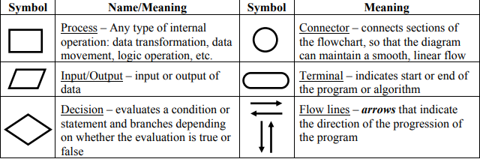

# **Flowchart Example**

Express an algorithm to get two numbers from the user (dividend and divisor), testing to make sure that the divisor number is not zero, and displaying their quotient using a flowchart.

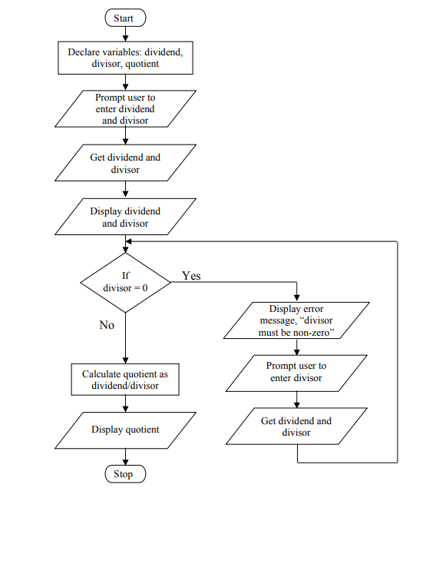

# **Control Structures of Programming**

In 1966, computer scientists Corrado Böhm and Giuseppe Jacopini demonstrated that all programs could be written using three control structures.

* Sequence (Sequential logic)
* Selection (Conditional statement)
* Repetition (Loop condition)

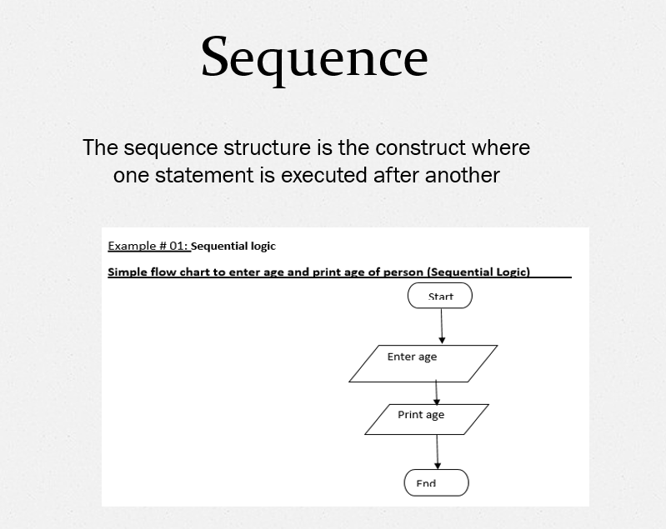 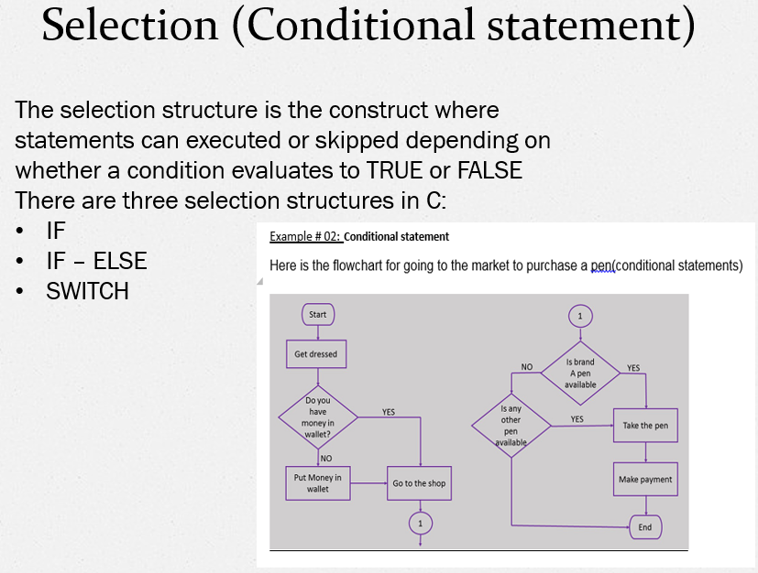 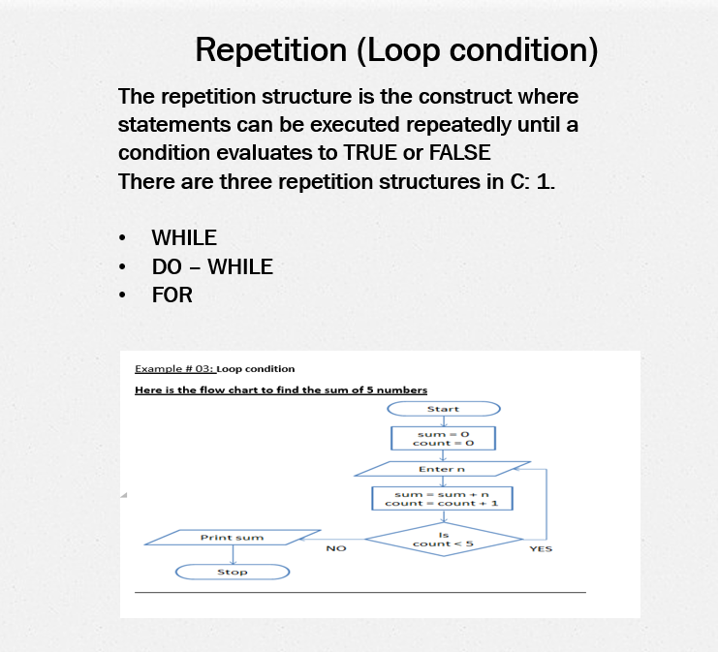 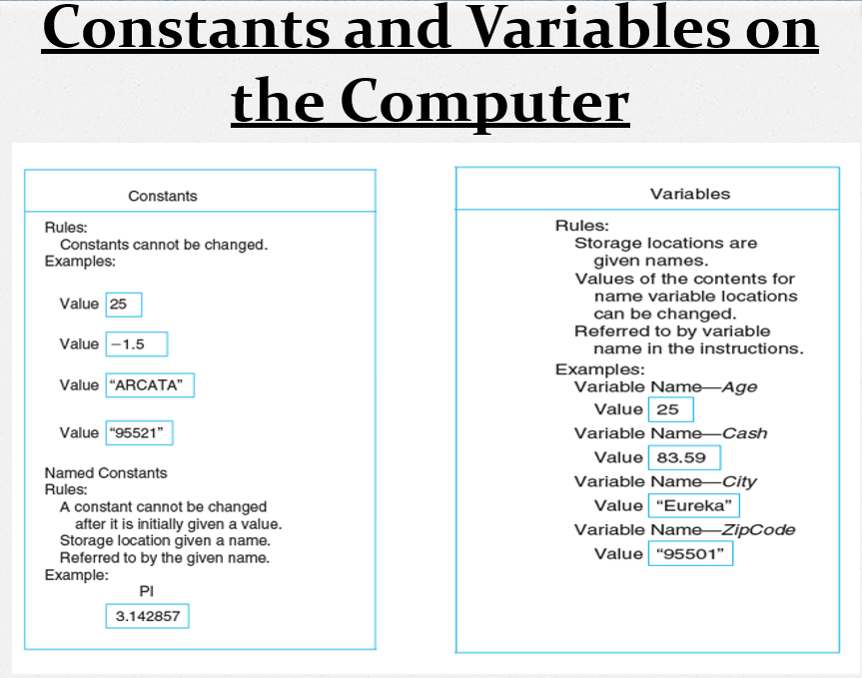

# **Rules for Naming and Using Variables**

* Name a variable according to what it represents.
* Do not use spaces.
* Start a variable name with a letter.
* Do not use a dash or any other symbol that is used as a mathematical operator.
* Consistent usage of variable name.
* Consistent use of upper, lowercase characters in variable names

Use naming convention specified by your company

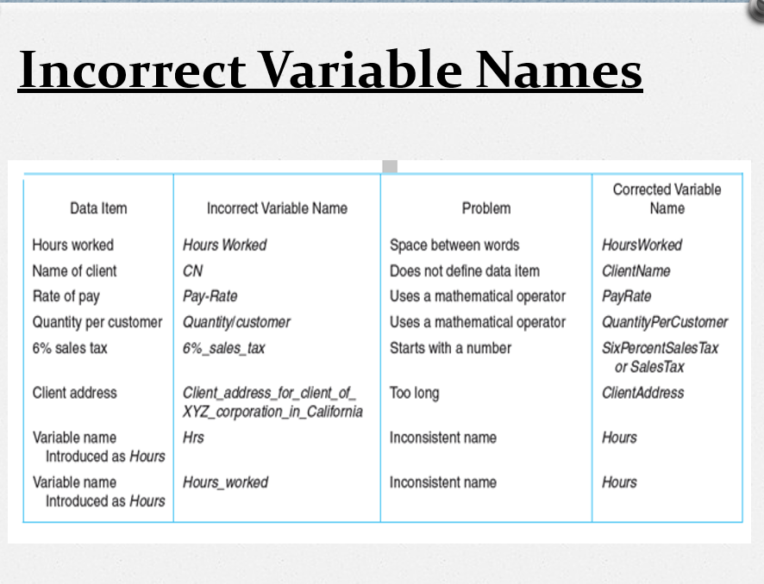

# **Class Tasks**

Q:1 – Write an algorithm and also draw a flowchart that performs addition of two numbers?

Q:2 - Write an algorithm and also draw a flowchart that prints hello world 10 times?

Q:3 – Write an algorithm and also draw a flowchart to login to Facebook account?

Q:4 – Write an algorithm and also draw a flowchart To Find All Numbers Between 1 To 100 Divisible By 4

Q:5 – Write an algorithm and also draw a flowchart To Find The Factorial Of A Number?

Q:6 – Write an algorithm and also draw a flowchart to convert given number of days in terms of Years, Weeks and Days?

No of days = 400

Q:7 – Write an algorithm and also draw a flowchart to check year is “leap year or not”?

Q:8 – Draw a flowchart for appointment scheduling in a private hospital?

Q:9 – Draw a flowchart that depicts grocery shopping on an online store?